# Workshop: Personal Portfolio

The workshop is part of the ["JavaScript For Front-End Course @ SoftUni"](https://softuni.bg/trainings/2032/javascript-for-front-end-july-2018#lesson-8965).

Submit your **portfolio** at course [page](https://softuni.bg/trainings/2032/javascript-for-front-end-july-2018#lesson-8976) and wait for your colleagues opinions.

It’s **NOT** mandatory to follow this design. You can create your **own** **personal** **portfolio**, just follow this constraints.

## Constraints:

* Your design should be based on [Bootstrap](https://getbootstrap.com/)
* Your custom **CSS** should be written on [SASS](https://sass-lang.com/)
* Your portfolio should be **responsive** – Good reason to use [Bootstrap Grid System](https://getbootstrap.com/docs/4.0/layout/grid/)
* You can add some additional **functionality** with [Bootstrap Plugins](https://startbootstrap.com/bootstrap-resources) or [jQuery Plugins](https://speckyboy.com/free-jquery-plugins/)
* You should **create** and **import** your own [favicon](https://www.favicon-generator.org/)
* You will be a real superhero if you **host** your portfolio in [Github Pages](https://pages.github.com/)

## Getting started with Bootstrap

It’s time to create your first personal portfolio using **Bootsrap**. First of all you should download the library from official [website](https://getbootstrap.com/). After that it’s time to create your **initial** **page**.

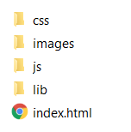

You should include **all** **bootstrap** **files** that you downloaded + [jQuery](https://jquery.com/).

### 2. 1. Theming Bootstrap

For our portfolio we can use **free** **Bootstrap** **theme** from [Bootswatch](https://bootswatch.com/). The theme that we will use in this workshop is [Minty](https://bootswatch.com/minty/), but you can use another one if you like it more. Simply download the **theme** **CSS** file and **replace** the one in **Bootstrap**. Now it’s time to look our **page** **structure**. It can be whatever you like so you are free to **design** it for yourself.

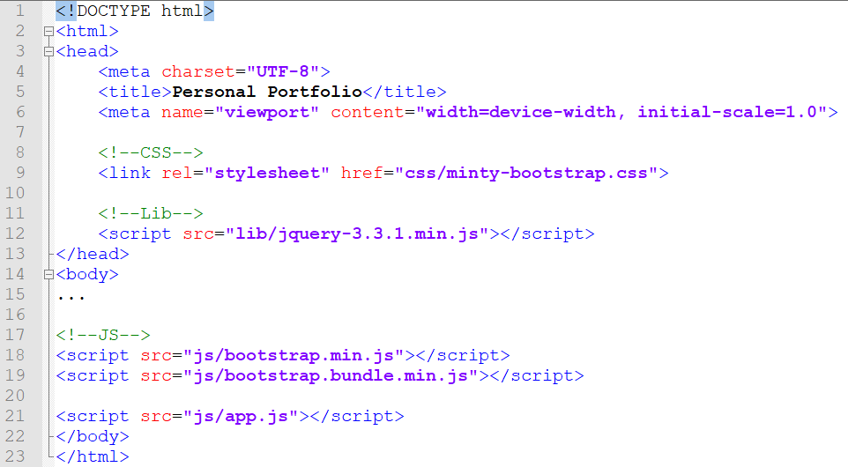

## Getting started with SASS

First of all make sure that you have **installed** [Node.js](https://nodejs.org/en/).

Install **SASS** from your [terminal](https://www.npmjs.com/package/node-sass).

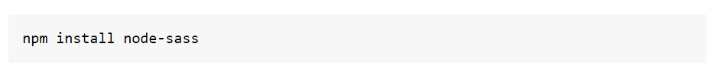

Configure your **IDE** to compile **SASS** to **CSS**.

* [WebStorm](https://www.jetbrains.com/help/webstorm/transpiling-sass-less-and-scss-to-css.html)

In the **Settings/Preferences** dialog click **File Watchers** under **Tools**. The [File Watchers page](https://www.jetbrains.com/help/webstorm/settings-tools-file-watchers.html) that opens, shows the list of File Watchers that are already configured in the project.

Click “**+**” or press Alt + Insert. Choose the **SCSS** predefined template from the list.

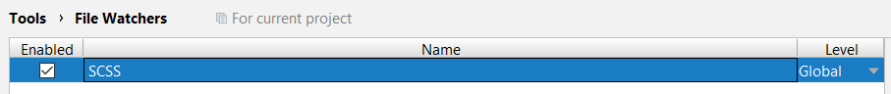

In **AppData\Roaming\npm** find your **node-sass.cmd** file and make sure you have the following **settings**.

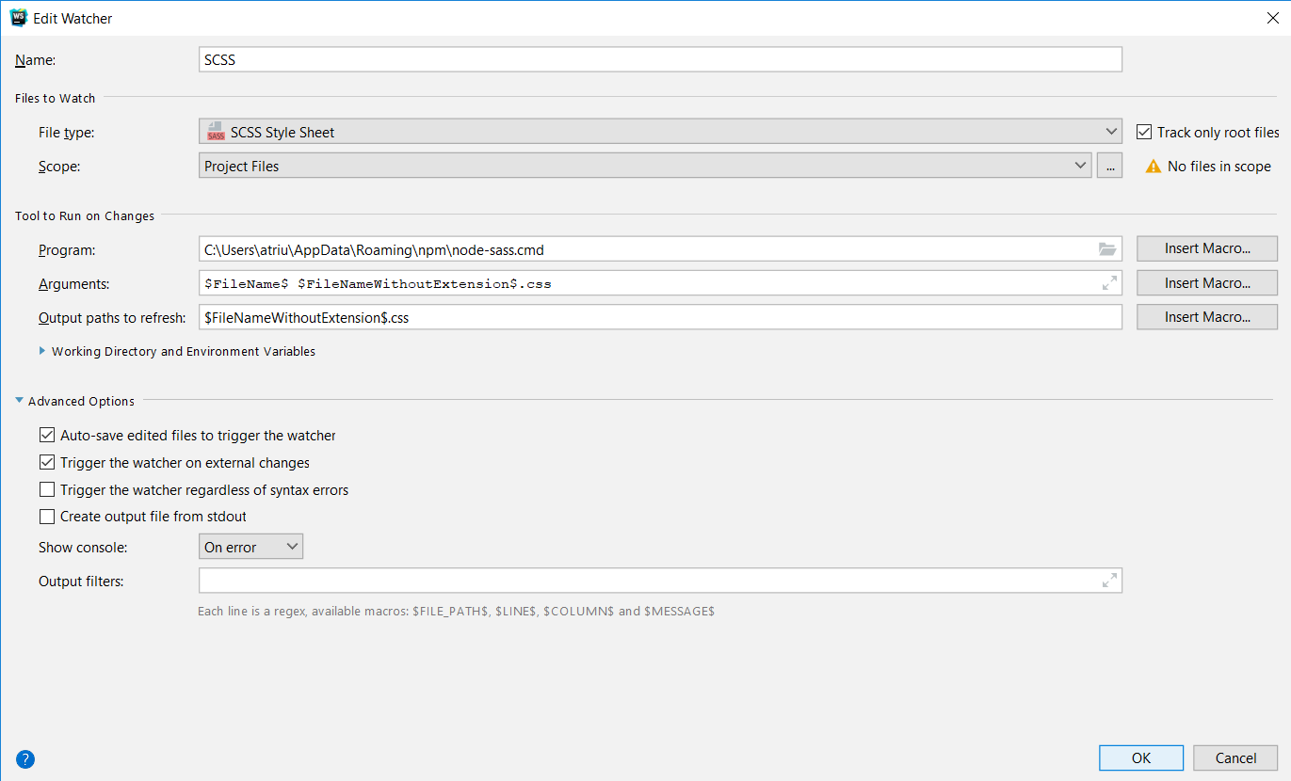

Create your first **SCSS** file and write some **Syntactically** **Awesome** **Style** **Sheets.**

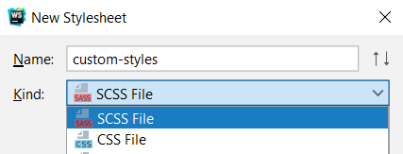

More about SASS Syntax [here](https://sass-lang.com/guide).

## Create Portfolio Page with Bootstrap

First of all we will need **navigation** bar. When we look at **theme** **documentation** we can see what kind of components she offers to us.

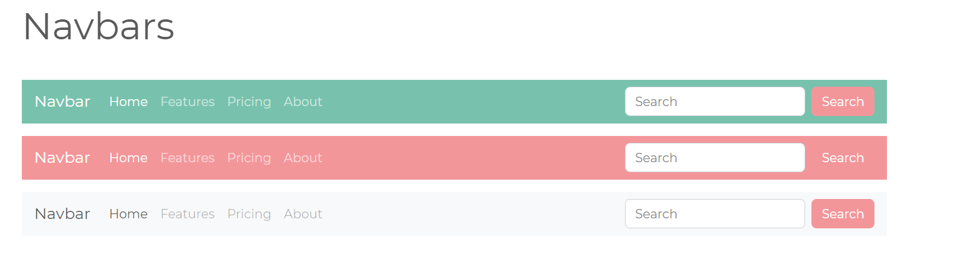

Well, our idea of similar but it will need little **changes**.



Our first section is **About**. So in our theme documentation we can see how we can create container and after that we just need to center it and to change the content inside.

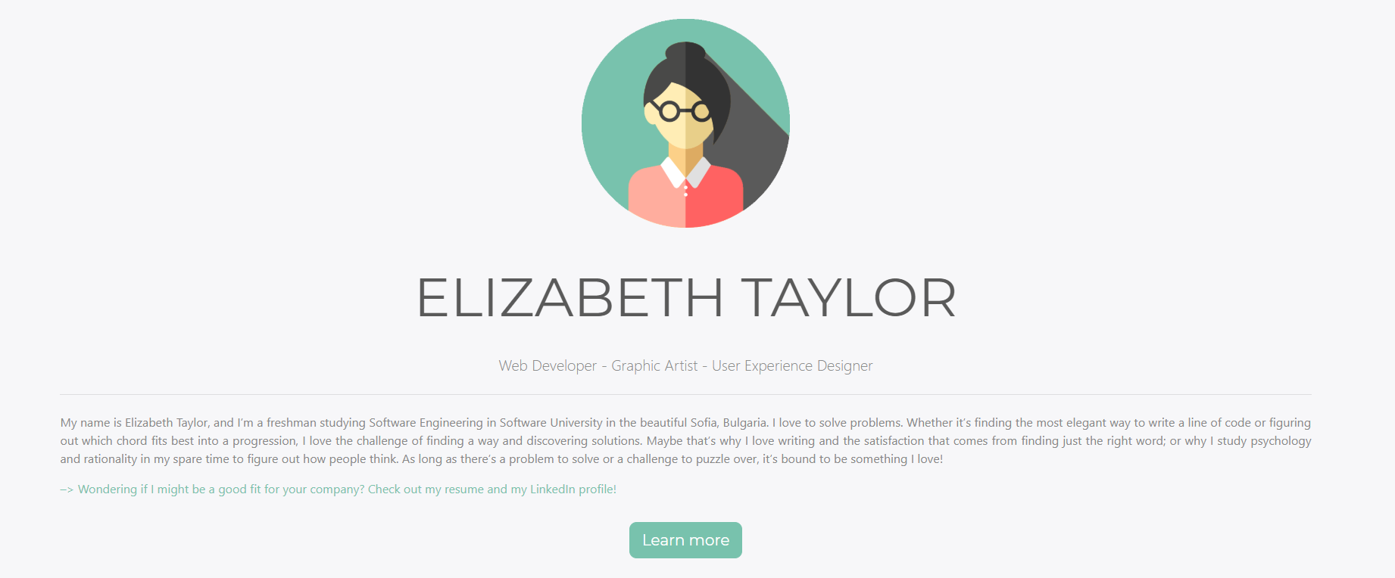

**Experience** and **Skills** sections looks similar too. So we can import some **cards** and **progress** **bar** **templates** and add little more content inside again.

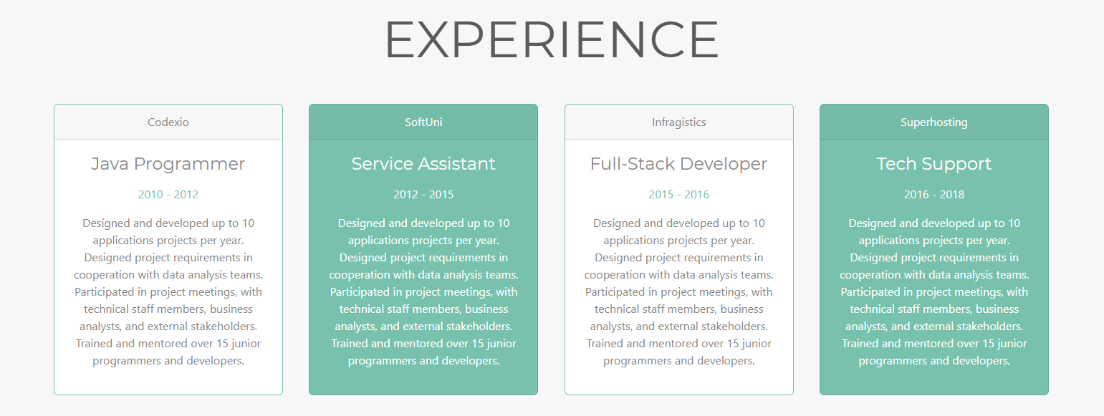

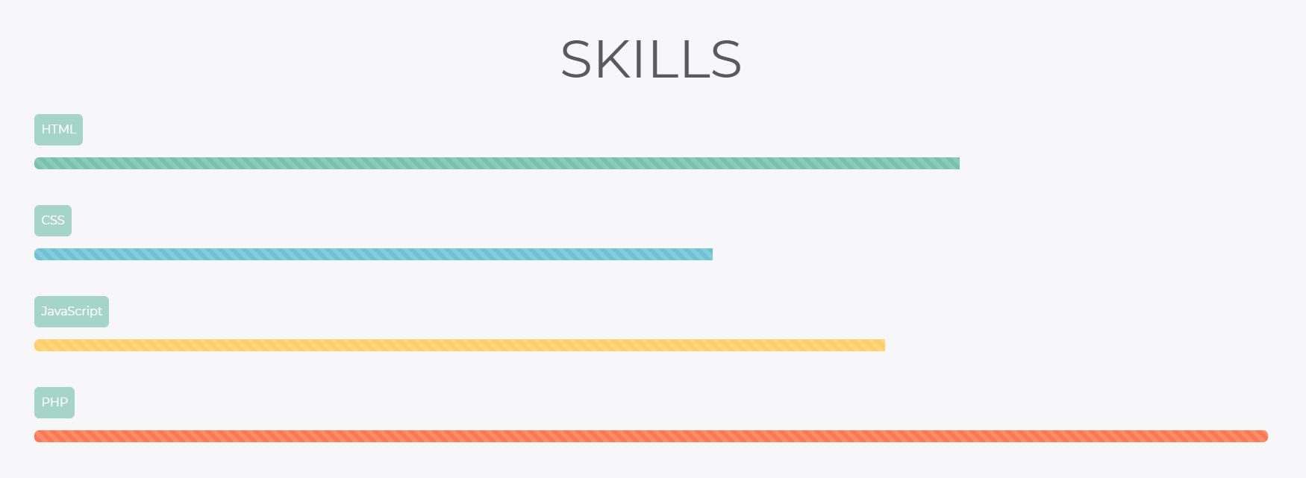

## Bootstrap and jQuery Plugins

So now the easy job is done and we should import some **custom** **plugins** in our portfolio.

## 5.1 Bootstrap Collapse

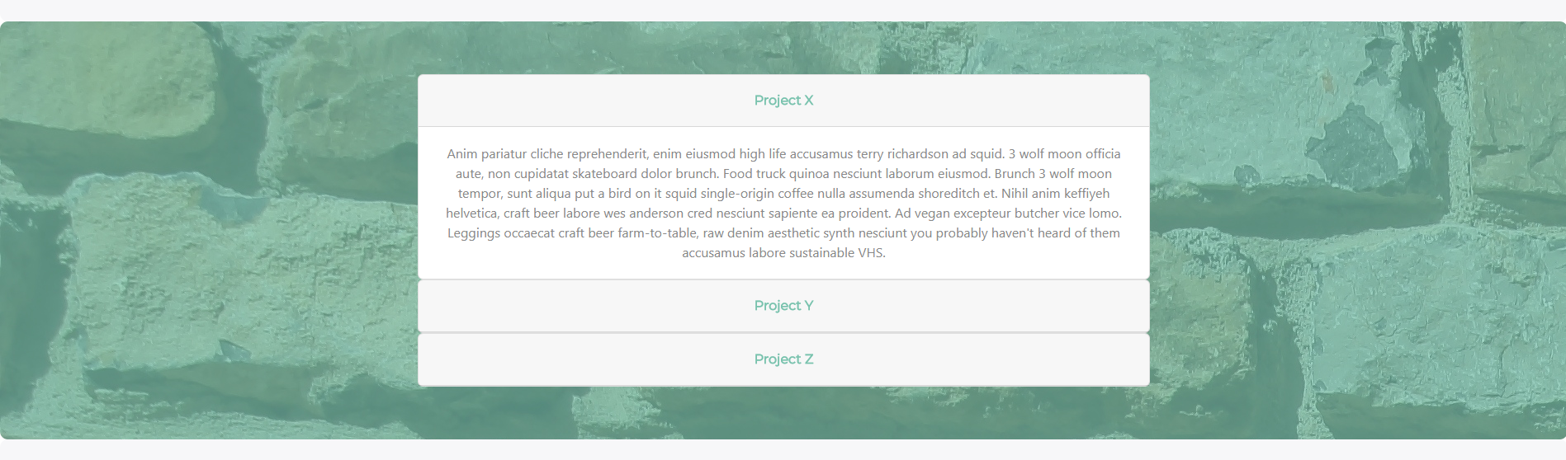

In **Projects** section we can use **collapse** **component**. You can read more about it in [Bootsrap official documentation](https://getbootstrap.com/docs/4.0/components/collapse/).

But first we need to import our **bootstrap.bundle.js** file and [jQuery](https://jquery.com/) library.

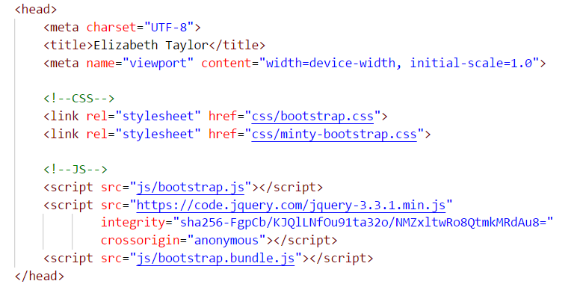

In **Contact** section we need to implement one little form which we can **reuse** from theme documentation.

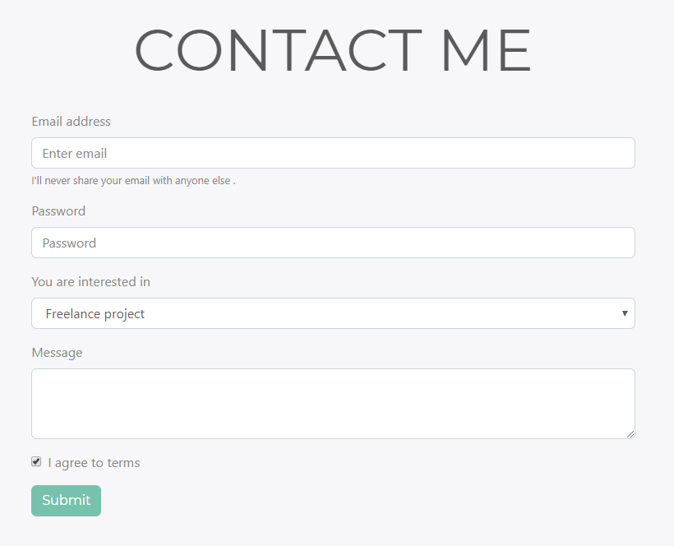 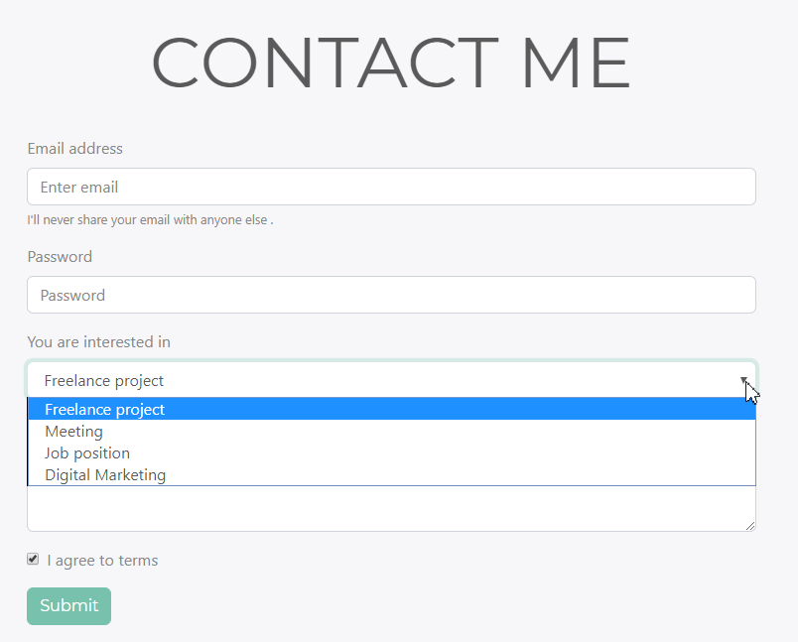

## Smooth Scroll with jQuery

After you create your **navigation** **bar** it’s time to **upgrade** it and to implement **smooth** **scroll** to it. You can use some **plugin** to do that or make it this little piece of **jQuery** code. Find different [solutions](https://css-tricks.com/snippets/jquery/smooth-scrolling/) to solve this problem.

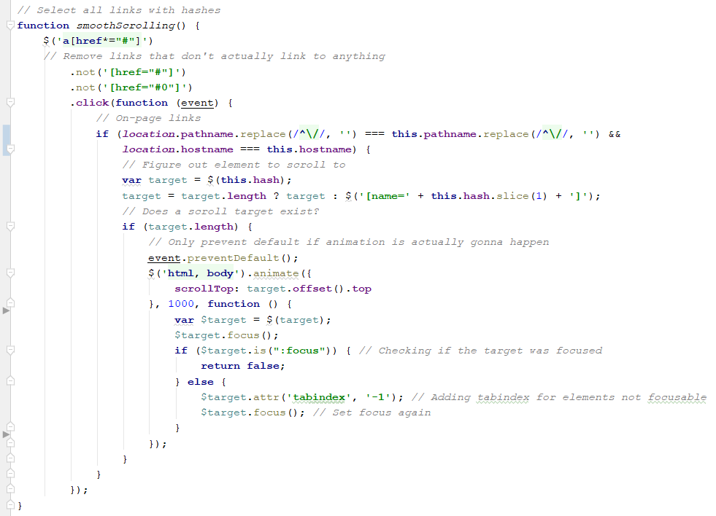

## Favicon

To have fully **completed** portfolio site you should not forget to add your **favicon**. You can use [favicon generator](https://realfavicongenerator.net/) online and upload some of your photos there.

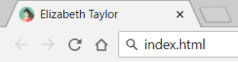

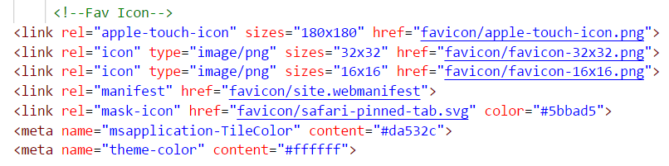

## Github Pages

After created this awesome portfolio it’s time to show it to the world. You can **host** your **simple** **static** portfolio in [Github Pages](https://pages.github.com/). First of all you should **create a repository** (like **username.github.io**), where username is your portfolio based name.

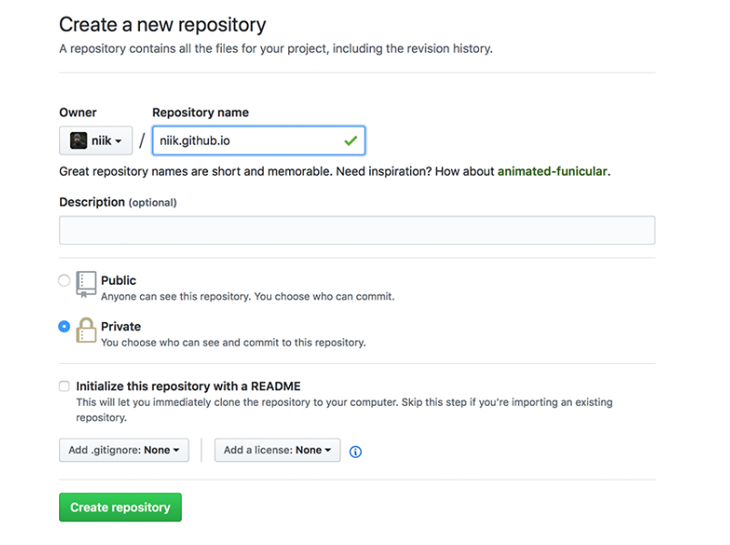

If you don’t use any **git** **client** we recommend you to download [GitHub Desktop](https://desktop.github.com/). **Clone** the repository you created and move your **portfolio** **project** there.

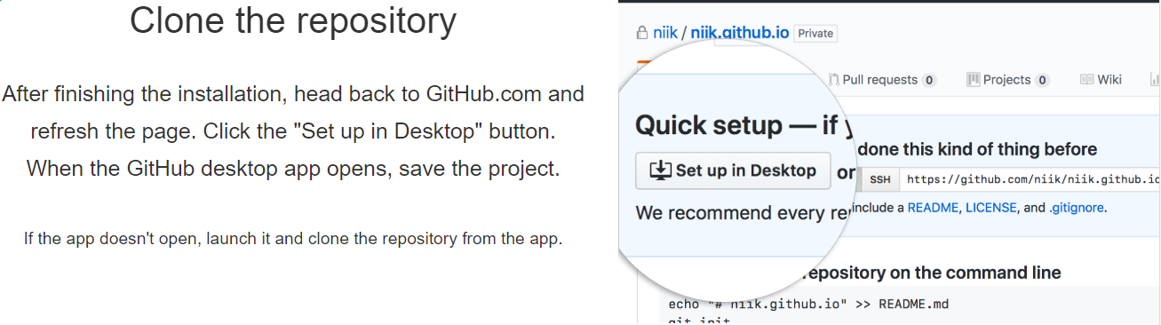

Enter the repository, **commit** your changes, and press the **publish** button.с

Fire up a browser and go to [**https://my-portfolio.github.io**](https://my-portfolio.github.io). Congratulations, now you can send it to everyone!